Telinfy WhatsApp API Documentation

- Template API
- Conversation API
- Campaign API
- Partner Webhook API

Tech Partner: Updated API V1
Last Updated: December 10-12-2024

Telinfy Platforms
Telinfy WhatsApp business account is a unique identifier inside the platform to do operations on registered WhatsApp business accounts. All the WhatsApp operations inside the Telinfy platform are based on this business account. The App ID, App Name, API Key, Access Token and webhook registration will be shared by the Telinfy support team as part of the onboarding process.

Important parameters

API Key
Each Telinfy account is assigned a unique API key. To access your API key, log in to your Telinfy account using your username and password. Navigate to the My Account section, where you'll find your API key listed under the API Key section.

Template Name
– A template name in WhatsApp refers to the unique identifier assigned to a message template that businesses use to send pre-approved, structured messages. These templates are typically used for notifications, updates, or transactional messages sent to users who have opted in to receive communication

Template languages
Template languages in WhatsApp refer to the specific languages in which a message template can be created and sent. WhatsApp supports multi-language templates to enable businesses to communicate with users in their preferred language, ensuring better engagement and understanding.

Media & Interactive
Multimedia such as Image, Video & PDF Should be passed as link with their corresponding extensions.
The Supported Formats for Media Upload while adding templates are:
Image: PNG & JPG
Video: MP4
Document: PDF

Template API Messaging
Template messages are the set of messages which the entity sends to its customer. Every new message sent from the entity to customer should be approved by WhatsApp. Template approval can be taken from Telinfy platforms. Once approved these templates can be used for campaign and API integration with various applications.

Simple Text Message
Post | https://api.telinfy.net/gaca/whatsapp/templates/message
Header-Api-Key | API Key Available in settings under your Telinfy Account
Template Body | {  "to": "+91XXXXXXXXXX",  "templateName": "TEMPLATENAME",  "language": "LANGUAGE",  "header": null,  "body": null,  "button": null  }
Response | {  "data": {  "messageId": "XXXXXXXXXX",  "whatsAppBusinessId": "XXXXXXXXXX",  "from": "YOURWABANUMBER",  "to": "ENDUSERNUMBER",  "source": "Api-Key",  "campaignId": null,  "status": "ACCEPTED",  "statusCode": null,  "wamId": "XXXXXXXXXX",  "response": null,  "isBilled": false,  "createTime": "2024-12-10T08:28:11.003Z",  "updateTime": "2024-12-10T08:28:11.003Z"  },  "message": "Message created successfully"  }

Text Message with Variable
Post | https://api.telinfy.net/gaca/whatsapp/templates/message
Header-Api-Key | API Key Available in settings under your Telinfy Account
Template Body | {  "to": "+91XXXXXXXXXX",  "templateName": "TEMPLATENAME",  "language": "LANGUAGE",  "header": null,  "body": {  "parameters": [  {  "type": "text",  "text": "template message sending"  },  {  "type": "text",  "text": "Test User"  }  ]  },  "button": null  }
Response | {  "data": {  "messageId": "XXXXXXXXXXXXXXXXXX",  "whatsAppBusinessId": "XXXXXXXXXXXXX",  "from": "YOURWABANUMBER",  "to": "ENDUSERNUMBER",  "source": "Api-Key",  "campaignId": null,  "status": "ACCEPTED",  "statusCode": null,  "wamId": "XXXXXXXXXXXXXXXXX",  "response": null,  "isBilled": false,  "createTime": "2024-12-10T08:28:11.003Z",  "updateTime": "2024-12-10T08:28:11.003Z"  },  "message": "Message created successfully"  }

Text Message with Image
Post | https://api.telinfy.net/gaca/whatsapp/templates/message
Header-Api-Key | API Key Available in settings under your Telinfy Account
Template Body | {  "to": "+91XXXXXXXXXX",  "templateName": "TEMPLATENAME",  "language": "LANGUAGE",  "header": {  "parameters": [  {  "type": "image",  "image": {  "link": "https://images.png"  }  }  ]  },  "body": null,  "button": null  }
Response | {  "data": {  "messageId": "XXXXXXXXXXXXXXXXXX",  "whatsAppBusinessId": "XXXXXXXXXXXXXXXX",  "from": "YOURWABANUMBER",  "to": "ENDUSERNUMBER",  "source": "Api-Key",  "campaignId": null,  "status": "ACCEPTED",  "statusCode": null,  "wamId": "XXXXXXXXXXXXXXXXXXXX",  "response": null,  "isBilled": false,  "createTime": "2024-12-10T08:28:11.003Z",  "updateTime": "2024-12-10T08:28:11.003Z"  },  "message": "Message created successfully"  }

Text message with PDF
Post | https://api.telinfy.net/gaca/whatsapp/templates/message
Header-Api-Key | API Key Available in settings under your Telinfy Account
Template Body | {  "to": "+91XXXXXXXXXX",  "templateName": "TEMPLATENAME",  "language": "LANGUAGE",  "header": {  "parameters": [  {  "type": "document",  "image": {  "link": "https://www.PDF.PDF",  "filename": "sample file name"  }  }  ]  },  "body": null,  "button": null  }
Response | {  "data": {  "messageId": "XXXXXXXXXXXXXXXXXXXX",  "whatsAppBusinessId": "XXXXXXXXXXXXXXXXXX",  "from": "YOURWABANUMBER",  "to": "ENDUSERNUMBER",  "source": "Api-Key",  "campaignId": null,  "status": "ACCEPTED",  "statusCode": null,  "wamId": "XXXXXXXXXXXXXXxx",  "response": null,  "isBilled": false,  "createTime": "2024-12-10T08:28:11.003Z",  "updateTime": "2024-12-10T08:28:11.003Z"  },  "message": "Message created successfully"  }

Text message with Video
Post | https://api.telinfy.net/gaca/whatsapp/templates/message
Header-Api-Key | API Key Available in settings under your Telinfy Account
Template Body | {  "to": "91XXXXXXXXXX",  "templateName": "TEMPLATENAME",  "language": "LANGUAGE",  "header": {  "parameters": [  {  "type": "video",  "video": {  "link": "https://www.videoxxxxxxx.mp4/"  }  }  ]  },  "body": null,  "button": null  }
Response | {  "data": {  "messageId": "XXXXXXXXXXXXX",  "whatsAppBusinessId": "XXXXXXXXXXXXXXXX",  "from": "YOURWABANUMBER",  "to": "ENDUSERNUMBER",  "source": "Api-Key",  "campaignId": null,  "status": "ACCEPTED",  "statusCode": null,  "wamId": "XXXXXXXXXXXXXXXXXX,  "response": null,  "isBilled": false,  "createTime": "2024-12-10T08:28:11.003Z",  "updateTime": "2024-12-10T08:28:11.003Z"  },  "message": "Message created successfully"  }

Text message with Audio
Post | https://api.telinfy.net/gaca/whatsapp/templates/message
Header-Api-Key | API Key Available in settings under your Telinfy Account
Template Body | {  "to": "91XXXXXXXXXX",  "templateName": "TEMPLATENAME",  "language": "LANGUAGE",  "header": {  "parameters": [  {  "type": "audio",  "audio": {  "link": "https://www.sounxxxxxx.mp3/"  }  }  ]  },  "body": null,  "button": null  }
Response | {  "data": {  "messageId": "XXXXXXXXXXXXXXXXXXX",  "whatsAppBusinessId": "XXXXXXXXXXXXXXX",  "from": "91XXXXXXXXXX",  "to": "ENDUSERNUMBER",  "source": "Api-Key",  "campaignId": null,  "status": "ACCEPTED",  "statusCode": null,  "wamId": "XXXXXXXXXXXXXX",  "response": null,  "isBilled": false,  "createTime": "2024-12-10T08:28:11.003Z",  "updateTime": "2024-12-10T08:28:11.003Z"  },  "message": "Message created successfully"  }

Text message with Button URL
Post | https://api.telinfy.net/gaca/whatsapp/templates/message
Header-Api-Key | API Key Available in settings under your Telinfy Account
Template Body | {  "to": "91XXXXXXXXXX",  "templateName": "TEMPLATENAME",  "language": "en",  "header": null,  "body": null,  "button": [  {  "sub_type": "url",  "index": 1,  "parameters": [  {  "type": "text",  "text": "home"  }  ]  }  ]  }
Response | {  "data": {  "messageId": "XXXXXXXXXXXXXXXXXX",  "whatsAppBusinessId": "XXXXXXXXXXXXXXXXXXXXX",  "from": "91XXXXXXXXXX",  "to": "ENDUSERNUMBER",  "source": "Api-Key",  "campaignId": null,  "status": "ACCEPTED",  "statusCode": null,  "wamId": "XXXXXXXXXXXXXXXXXX",  "response": null,  "isBilled": false,  "createTime": "2024-12-10T08:28:11.003Z",  "updateTime": "2024-12-10T08:28:11.003Z"  },  "message": "Message created successfully"  }

Campaign API
How to create campaigns?
Telinfy allows you to create campaigns by using the following api. First, you need to upload an excel file containing numbers to send. You have to select a particular template for the campaign which will be sent to the contacts you selected.

Part 1 File Upload
Post | https://fs.telinfy.net/adapter/files/upload?whatsAppBusinessId=[YourChannelID]
Params - whatsAppBusinessId | 7049a51f-aafb-414XXXXXXXXXX
Header – API Key | Your API Key
Body – Form Data | Key – File, Value – Upload JSON File
Sample JSON Format | [  {  "to": "+91XXXXXXXXXX ",  "templateName": "TEMPLATENAME",  "language": "LANGUAGE",  "header": null,  "body": {  "parameters": [  {  "type": "text",  "text": " sample "  },  {  "type": "text",  "text": "sample"  }  ]  },  "button": null  },  {  "to": "+91XXXXXXXXXX",  "templateName": "TEMPLATENAME",  "language": "LANGUAGE",  "header": null,  "body": {  "parameters": [  {  "type": "text",  "text": "username"  },  {  "type": "text",  "text": "username"  }  ]  },  "button": null  }  ]
Response | {  "data": {  "fileId": "XXXXXXXXXXXXXXXXX",  "name": "test-camp-msg-1.json",  "size": "547",  "whatsAppBusinessId": "4XXXXXXXXXXXXXXXXX",  "createdAt": "2024-12-05T06:30:38.548Z",  "url": "https://s3.ap-southXXXXXXXXXX.json"  },  "message": "File created successfully"  }

Part 2 Campaign API
In this API to create a campaign, pass the field from the above file upload API as Campaign ID
Post | https://api.telinfy.net/telinfy-gcms/v4/whatsapp/campaign
Header-Api-Key | API Key Available in settings under your Telinfy Account
Template Body | {  "channelId": "channel_id",  "campaignId": "{{fileId}}", //Generated from file upload API  "campaignName": "test 02",  "channelGroupId": 3,  "scheduleTime": "2022-09-27T19:07:15.478Z",  "campaignMessageCount": 2  }
Response | {  "data": {  "campaignId": "XXXXXXXXXXXXXX",  "whatsAppBusinessId": "XXXXXXXXXXXXXX",  "phoneNumberId": "XXXXXXXXXXXXXX",  "campaignName": "CT-02",  "scheduleTime": "2022-09-27T19:07:15.478Z",  "status": "CREATED",  "source": "PostmanRuntime/7.36.1",  "channelGroupId": 3,  "creationInstanceId": null,  "schedulingInstanceId": null,  "messageBucketId": "3",  "from": "91XXXXXXXXXXXXX"  },  "message": "Created Successfully"  }

Media File Hosting
Post | https://fs.telinfy.net/adapter/files/upload?whatsAppBusinessId=[YourChannelID]
Params - whatsAppBusinessId | 7049aXXXXXXXXXXb-414XXXXXXXXXX
Header – API Key | Your API Key
Body – Form Data | Key – File, Value – Select file
File | (Image, video or PDF)
Response | {  "data": {  "fileId": "XXXXXXXXXXXXXXXXXXXXxxx",  "name": "XXXXXXXXXXXX”,  "size": "XXXXXXXXXx",  "whatsAppBusinessId": "XXXXXXXXXXXXXX",  "createdAt": "2025-02-26T09:07:17.326Z",  "url": "https://s3.ap-south-1.amazo30.jpg/mp4/pdf"  },  "message": "File created successfully"  }

Conversation APIs
You can participate in a direct conversation / chat with a customer only if you are in a Customer Service Window. Which means the customer should be replied to your template message within the last 24 hours. If the customer’s last message is 24 hours before and if you try to send a normal message to the customer, it won’t be successful. If you need to resume a conversation with that customer, you must send a template message to the customer, and he/she should reply to you. Direct messaging supports the following message types: Text message, media messages, contacts and location messages and interactive messages.

Simple Reply to a conversation
Post | https://api.telinfy.net/gaca/whatsapp/message/direct
Header-Api-Key | API Key Available in settings under your Telinfy Account
Template Body | {  "to": "91XXXXXXXXXX",  "type": "text",  "text": {  "body": "Lorem ipsum"  }  }
Response | {  "data": {  "conversationMessageId": "XXXXXXXXXXXXXX",  "conversationId": "XXXXXXXXXXXXx",  "messageBody": {  "messaging_product": "whatsapp",  "recipient_type": "individual",  "to": "+91XXXXXXXXXX",  "type": "text",  "text": {  "body": "Lorem ipsum dolor sit amet, consectetur adipiscing elit. Aliquam eu accumsan nibh.."  }  },  "messageType": "text",  "wamId": "XXXXXXXXXXXXXXXXXXX",  "response": null,  "status": "ACCEPTED",  "statusCode": null,  "isInbound": false,  "isQuickReply": false,  "parent": null,  "isBot": false,  "callbackData": null,  "isBilled": false,  "createTime": "2024-12-10T12:30:39.269Z",  "updateTime": "2024-12-10T12:30:39.269Z"  },  "message": "Message created successfully"  }

Conversation API to send an Image
Post | https://api.telinfy.net/gaca/whatsapp/message/direct
Header-Api-Key | API Key Available in settings under your Telinfy Account
Template Body | {  "to": "+91XXXXXXXXXX",  "type": "image",  "image": {  "link": "https://s7.XXXXXXXXXXX.jpg",  "caption": ""  }  }
Response | {  "data": {  "conversationMessageId": "XXXXXXXXXXXXXX",  "conversationId": "XXXXXXXXXXXX",  "messageBody": {  "messaging_product": "whatsapp",  "recipient_type": "individual",  "to": "+91XXXXXXXXXX",  "type": "image",  "image": {  "link": "https://s7.gifyu.coXXXXXXXXXXXX.jpg",  "caption": ""  }  },  "messageType": "image",  "wamId": "XXXXXXXXXXXXXX",  "response": null,  "status": "ACCEPTED",  "statusCode": null,  "isInbound": false,  "isQuickReply": false,  "parent": null,  "isBot": false,  "callbackData": null,  "isBilled": false,  "createTime": "2024-12-10T12:34:31.517Z",  "updateTime": "2024-12-10T12:34:31.517Z"  },  "message": "Message created successfully"  }

Conversation API to send a video
Post | https://api.telinfy.net/gaca/whatsapp/message/direct
Header-Api-Key | API Key Available in settings under your Telinfy Account
Template Body | {  "to": "91XXXXXXXXXX",  "type": "video",  "video": {  "link": "yourlink",  "caption": "Did you like this video?"  }  }
Response | {  "data": {  "conversationMessageId": "XXXXXXXXXXXXX",  "conversationId": "XXXXXXXXXXXXXXXX",  "messageBody": {  "messaging_product": "whatsapp",  "recipient_type": "individual",  "to": "+91XXXXXXXXXX",  "type": "video",  "video": {  "link": "https://s3.ap-XXXXXXXXXXX.mp4",  "caption": "Did you like this video?"  }  },  "messageType": "video",  "wamId": "XXXXXXXXXXX",  "response": null,  "status": "ACCEPTED",  "statusCode": null,  "isInbound": false,  "isQuickReply": false,  "parent": null,  "isBot": false,  "callbackData": null,  "isBilled": false,  "createTime": "2024-12-10T12:53:40.351Z",  "updateTime": "2024-12-10T12:53:40.351Z"  },  "message": "Message created successfully"  }

Conversation API to send a document
Post | https://api.telinfy.net/gaca/whatsapp/message/direct
Header-Api-Key | API Key Available in settings under your Telinfy Account
Template Body | {  "to": "91XXXXXXXXXX",  "type": "document",  "document": {  "link": "https: //s3.ap-southXXXXXXXXXX.pdf",  "filename": "GreenAdsDoc",  "caption": "just a sample document"  }  }
Response | {  "data": {  "conversationMessageId": "XXXXXXXXXX",  "conversationId": "XXXXXXXXXXXX",  "messageBody": {  "messaging_product": "whatsapp",  "recipient_type": "individual",  "to": "+ 91XXXXXXXXXX",  "type": "document",  "document": {  "link": "https: //s3.ap-southXXXXXXX.pdf",  "caption": "just a sample document"  }  },  "messageType": "document",  "wamId": "XXXXXXXXXXXX",  "response": null,  "status": "ACCEPTED",  "statusCode": null,  "isInbound": false,  "isQuickReply": false,  "parent": null,  "isBot": false,  "callbackData": null,  "isBilled": false,  "createTime": "2024-12-10T13:01:39.984Z",  "updateTime": "2024-12-10T13:01:39.984Z"  },  "message": "Message created successfully"  }

Conversation API to send an audio
Post | https://api.telinfy.net/gaca/whatsapp/message/direct
Header-Api-Key | API Key Available in settings under your Telinfy Account
Template Body | {  "to": "91XXXXXXXXXX",  "type": "audio",  "audio": {  "link": "https://www.soxxxxxxx.com/XXXXX.mp3"  }  }
Response | {  "data": {  "conversationMessageId": "XXXXXXXXXXXX",  "conversationId": "XXXXXXXXXXX",  "messageBody": {  "messaging_product": "whatsapp",  "recipient_type": "individual",  "to": "91XXXXXXXXXX",  "type": "audio",  "audio": {  "link": "https://www.souxxxxxxx.com/XXXXX.mp3"  }  },  "messageType": "audio",  "wamId": "XXXXXXXXXXXXXXXXXX",  "response": null,  "status": "ACCEPTED",  "statusCode": null,  "isInbound": false,  "isQuickReply": false,  "parent": null,  "isBot": false,  "callbackData": null,  "isBilled": false,  "createTime": "2024-12-10T13:03:25.792Z",  "updateTime": "2024-12-10T13:03:25.792Z"  },  "message": "Message created successfully"  }

Conversation API to send Interactive List
Post | https://api.telinfy.net/gaca/whatsapp/message/direct
Header-Api-Key | API Key Available in settings under your Telinfy Account
Template Body | {  "to": "+91xxxxxxxxxxx",  "type": "interactive",  "interactive": {  "type": "list",  "header": {  "type": "text",  "text": "👋 Welcome to Jaspers"  },  "body": {  "text": "Let us know how we can help you today by chossing local store"  },  "action": {  "button": "shops",  "sections": [  {  "title": "Our Shops",  "rows": [  {  "id": "01234",  "title": "Jaspers Clapham",  "description": "85A E Dulwich Grove, London SE22 8PU"  },  {  "id": "12345",  "title": "Jaspers Brixham",  "description": "419 Coldharbour Lane,SW9 BLH"  }  ]  }  ]  }  }  }
Response | {  "data": {  "conversationMessageId": "XXXXXXXXXX",  "conversationId": "XXXXXXXXXXX",  "messageBody": {  "messaging_product": "whatsapp",  "recipient_type": "individual",  "to": "+91XXXXXXXXX",  "type": "interactive",  "interactive": {  "type": "list",  "header": {  "type": "text",  "text": "👋 Welcome to Jaspers"  },  "body": {  "text": "Let us know how we can help you today by chossing local store"  },  "action": {  "button": "shops",  "sections": [  {  "title": "Our Shops",  "rows": [  {  "id": "01234",  "title": "Jaspers Clapham",  "description": "85A E Dulwich Grove, London SE22 8PU"  },  {  "id": "12345",  "title": "Jaspers Bixham",  "description": "419 Coldharbour Ln,SW9 BLH"  }  ]  }  ]  }  }  },  "messageType": "interactive",  "wamId": "XXXXXXXXXXX",  "response": null,  "status": "ACCEPTED",  "statusCode": null,  "isInbound": false,  "isQuickReply": false,  "parent": null,  "isBot": false,  "callbackData": null,  "isBilled": false,  "createTime": "2025-01-09T09:05:47.855Z",  "updateTime": "2025-01-09T09:05:47.855Z"  },  "message": "Message created successfully"  }

Partner Webhook

Introduction
Webhooks are a mechanism which enables applications to communicate with each other programmatically. It allows you to send real-time data from one application to another whenever a given event occurs. You can use the webhook to determine which endpoint we should forward the real-time data.
Whenever a specific event occurs, the WhatsApp Business API Client sees the event, collects the data, and immediately sends a notification (user-defined HTTP callbacks) to the webhook URL specified.

- messages: Used to notify you when you get a new message and what is in the new message.
- statuses: Used to notify you when there's a status change in a message you sent.
- errors: When there are any out-of-band errors that occur in the normal operation of the application, this array provides a description of the error.

To deploy a live partner-webhook that can receive events from the WhatsApp Business API client, your code must have HTTPS support and a valid SSL certificate.

Webhook URL
The webhook URL is a resource address to which the WhatsApp Servers sends notifications, which are triggered by specific events. A suitable webhook URL must be supplied by you or by your Partner Software Provider / ISV. You only need to set your Webhook URL once. Although you can update it or remove it at any time.
You must set a Webhook URL once per number.
Schema
POST [base-url]/whatsapp-business/accounts/partner-webhook
Parameters
Header
Content-Type string application/json Body
whatsAppBusinessId string
partnerWebhookUrl string - www.example.com/webhook / null

{
"whatsAppBusinessId": "6ba5e591-5e02-40be-afd7-d487bbed8110",
"partnerWebhookUrl": "www.example.com/webhook"
}

Responses 200:

This class of status codes indicates the action requested by the client was received, understood, and accepted.

{
"data": {
"whatsAppBusinessId": "6ba5e591-5e02-40be-afd7-d487bbed8110",
"accountId": "d65cd6a6-0ae3-4306-b668-d3897",
"displayName": "Accounting-cloud",
"businessAcountId": "26632543465436",
"apiKey": "AANS1IlRaOIBAHvCwTP1fmc211e1fd",
"status": "VERIFYING",
"partnerWebhookUrl": "www.example.com/webhook",
"quickReplyEnabled": "false",
"createTime": "2022-10-12T08:09:08.236Z",
"updateTime": "2022-10-12T08:09:08.223Z"
}
}

400:

The 400 Bad Request Error is an HTTP response status code that indicates that the server was unable to process the request sent by the client due to invalid syntax.

{
"status": 400,
"message": "Invalid url, please provide valid a https url"
}

500:

The HTTP status code 500 is a generic error code. It means that the server encountered an unexpected condition that prevented it from fulfilling the request.

{
"status": 500,
"message": "Internal server error"
}

Webhook Components
Webhooks have a top-level array field indicating what is being communicated. The members of the array are JSON objects with detailed fields relevant to the Webhook.
WhatsApp Business API webhooks can contain the following objects:

Name | Object contents
whatsappBusinessId | Your business account unique key
messages | Webhook notifications of received messages are contained within a messages object.
statuses | The statuses object keeps you apprised of the status of messages between you and users or groups.
errors | When there are any out-of-band errors that occur in the normal operation of the application, the errors array provides a description of the error. This type of error can be caused by transient network connectivity errors, invalid credentials, management controllers in unavailable status, etc.

The messages Object
Name | Description
contacts type: Array of contact profile information | Provides all the information about the contact —see contacts object. This object only applies to text, contacts, and location messages. It is not currently supported for media messages and is not applicable for system messages. Inside contacts, the profile object is nested.
messages type: Array of any type of message objects | Provides all of the information about the incoming message —see messages object. Inside messages, the following objects are nested: context, identity, media, referral, text, location, contacts, system, and interactive.

Contacts
The contacts object provides all the information about the contract.

Name | Description
profile type: Profile object | Contains the sender's profile information.
wa_id type: string | The WhatsApp ID of the contact.

Profile
This object contains the sender's profile information
Name | Description
name | Optional.
type: String | Contains the sender's profile name.

Messages
The messages object provides all of the information about the incoming message.
Name | Description
context type: Object | Optional. This object will only be included when someone replies to one of your messages. Contains information about the content of the original message, such as the ID of the sender and the ID of the message. See context object for more information.
From type: string | WhatsApp ID of the sender.
Id type: string | Message ID.
identity type: Identity Object | Optional. Contains information about the user identity used to decrypt the incoming message. See identity object.
timestamp type: String | Message received timestamp.
type type: String | Message type. Supported values are audio, contacts, document, image, location, text, unknown, video.
audio, contacts, document, image, location, system, text, button, and video objects. type: Object. | Message contents.
system type: System Object | Notifications of changes to the system. See system object for more information.
interactive type: Interactive Object | This object is present for notifications related to interactive messages. See interactive object for more information

Context
A context object is found in messages when a user replies or interacts with one of your messages. A user interacts with a message by inquiring for more information. context objects for interactions do not have the from and id fields.
Name | Description
from type: String | Optional. Will not be present if the user only interacts with the message. WhatsApp ID of the sender of the original message. WhatsApp ID of the sender of the original message.
id type: String | Optional. Will not be present if the user only interacts with the message. Message ID of original message.
referred_product | Used for enquiries coming from a Product Detail Page, Single Product Messages, and Multi-Product
type: object | Message

Referred_Product
Used for Single Product Messages. This object contains the item mentioned in the message.
Name | Description
catalog_id | ID for the catalog the item belongs to.
product_retailer_id | Unique identifier (in the catalog) of the product.

identity
The identity object provides all the information about the user's identity.
Name | Description
acknowledged type: String | State of acknowledgment for latest User_identity_changed system notification.
created_timesta mp type: Int | Timestamp of when the WhatsApp Business API client detected the user potentially changed.
hash type: String | Identifier for the latest user_identity_changed system notification.

text
When the notification describes a text message, the text object provides the body of the text message.
Name | Description
body type: String | Message text.

location
When you receive a notification of a user's static location, the location object provides the details of the location.
Name | Description
latitude type: Number | Latitude of location being sent.
longitude type: Number | Longitude of location being sent.
address type: String | Address of the location.
name type: String | Name of the location.
url type: String | URL for the website where the user downloaded the location information.

Note: Inbound messages of type live location are not currently supported

contacts
When you receive a notification of a user's contact information, the contacts object provides the contact information details.
This field is different from the contacts object listed above.
Name | Description
addresses type: Array | Full contat address(es). This field can contact street, city, state,zip,country,country_code and type fields
birthday type: YYYY-MM-DD formatted string | Contact's birthday.
emails type: Array | Contact email address(es). This field can contain the email and type parameters.
ims type: Array | Messaging contact information. This field contains the service and user_id parameters.
name type: Array | Full contact name. This field can contain the first_name, middle_name, last_name, formatted_name, name-prefix, and name_suffix parameters.
org type: Array | Contact organization information. This field can contain the company, department, and title parameters.
phones type: Array | Contact phone number(s). This field can contain the phone, wa_id, and type parameters.
urls type: Array | Contact URL(s). This field can contain the url and type parameters.

button
When the notification describes a button message, the button object provides the text of the button message. The button messages are received when the customers click on quick action buttons on interactive template messages.
Name | Description
text type: String | Button message text.

media
When a message with media (image | document | audio | video | sticker) is received, the WhatsApp Business API client will upload the media to aws s3 bucket and a notification is sent to your Webhook
Name | Description
Caption type: String | Optional: only present if specified The provided caption for the media
link Type: String | AWS S3 open Url link of the media
filename type: String | Filename on the sender's device. This will only be present in document media messages.
metadata type: Metadata object | Metadata pertaining to sticker media.
mime_type type: String | Mime type of the media.

system
Notifications of changes to the system are sent to the system object.

Name | Description
body type: String | System event message.

interactive
An interactive object is found in webhooks related to interactive messages, including List Messages and Reply Button. This object contains the following components:

Name | Description
type | Required for list_reply. Supported values: list_reply for List Messages button_reply for Reply Button Messages
list_reply | Used to notify you when customers are replying to ListMessages. Contains the following information about the rows selected by the customer: id, title, and description.
button_reply | Used to notify you when customers are replying to QuickReply Messages. Contains the following information about the button clicked by the customer: id and title.

CallbackData
Response contains user specified string in callbackData field if the message is a reply to a message. Otherwise callbackData field is null.
Example for message with callback data
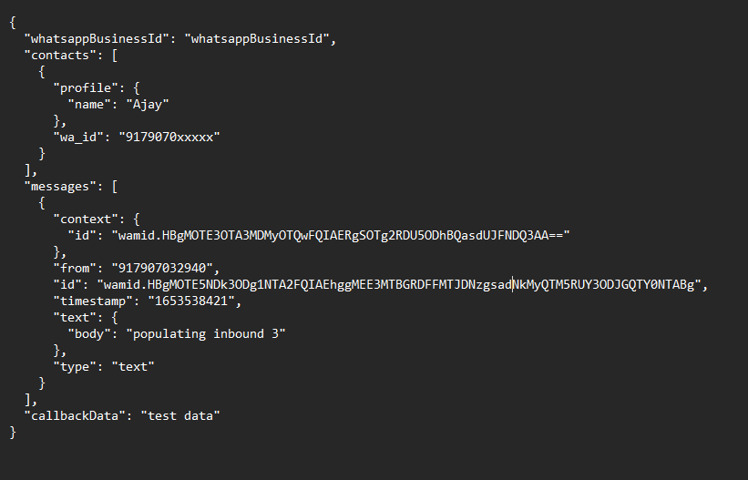

The statuses
Object The statuses object keeps you apprised of the status of messages between you and users or groups
Name | Description
id type: string | Message ID
recipient_id type: string | WhatsApp ID of recipient
status type: string | Status of a message.
timestamp type: string | Timestamp of the status message.
type type: string | The type of entity this status object is about. Currently, the only available option is "message".
conversation type: object | Object containing conversation attributes, including id. See conversation object for more information. WhatsApp defines a conversation as a 24-hour session of messaging between a person and a business. There is no limit on the number of messages that can be changed in the 24-hour window. The 24-hour conversation session begins when: A business-initiated message is delivered to a user A business’ reply to a user message is delivered the 24-hour conversation session is different from the 24-hour customer support window. The customer support window is a rolling window that is refreshed when a user-initiated message is delivered to a business. Within the customer support window businesses can send free-form messages. Any business- initiated message sent more than 24 hours after the last customer message must be a template message.
pricing type: object | Object containing billing attributes, including pricing_model, billable flag, and category. See pricing object for more information.

conversation
The conversation object tracks the attributes of your current conversation. The following fields are specified within the conversation object:
Name | Description
id type:string | Represents the ID of the conversation the given status notifications belongs to.
origin type: object | Describes where the conversation originated from.
expiration_ timestamp type: UNI timestamp | Timestamp when the current ongoing conversation expires. This field is only present on "message sent" webhooks.

origin
The origin object describes where a conversation has originated from. The following fields are specified within the origin object:

Name | Description
type type: string | Indicates where a conversation has started. This can also be referred to as a conversation entry point.

pricing
The pricing object includes your billing attributes but does not include whether a message is part of your account’s free tier. The following fields are specified within the webhooks pricing object:
Name | Description
pricing_model type: String. “CBP” or “NBP”. | Type of pricing model being used. The current supported value is "CBP". The Notification-Based Pricing (NBP) model has been deprecated.
billable type: boolean | Indicates if the given message or conversation is billable. Value varies according to pricing_model. This flag is set to false if the conversation was initiated from free entry points. Conversations initiated from free entry points are not billable. For all other conversations, it’s set to true. This is also set to true for Conversations inside your free tier limit. You will not be charged for these conversations, but they are considered billable and will be reflected on your invoice.  This flag is set to true for notification messages (template messages)
category type: string | Indicates the conversation pricing category.

The errors Object
The errors object contains the following parameters:
Name | Description
code type: Numeric | Error code.
title type: String | Error title.
details type: String | Optional. Error details provided, if available/applicable.
href type: String | Optional. Location for error detail.

Status Updates
For each message your business sends, you will receive a notification about the status of the message. In the table below, click the arrow in the left column for the WhatsApp app equivalent to each status, if available.
Name | Description
deleted | A message send by the user was deleted by the user. Upon receiving this notification, you should ensure that the message is deleted from your system if it was downloaded from the server.
delivered | A message sent by your business was delivered to the user's device.
failed | A message sent by your business failed to send. A reason for the failure will be included in the callback. Check the error message documentation for help debugging: On-Premises API Errors Cloud API Error Codes and Troubleshooting Cloud API Error Codes and Troubleshooting
read | A message sent by your business was read by the user. read notifications are only available for users that have read receipts enabled. For users that do not have it enabled; you only receive the delivered notification.
sent | A message sent by your business is in transit within our systems. For On-Premises API users: To receive notifications for sent messages, set the sent_status setting to true in the application settings. The sent status notification is disabled by default.
warning | A message your business sent contains an item in a catalog that is not available or does not exist. For a status to be read, it must have been delivered. In some scenarios, such as when a user is in the chat screen and a message arrives, the message is delivered and read almost simultaneously. In this or other similar scenarios, the delivered notification will not be sent back, as it is believed that a message has been delivered if it has been read. The reason for this behavior is internal optimization.

The order of these notifications in your app may not reflect the actual timing of the message status. View the timestamp to determine the timing, if necessary.

Examples

Text Messages
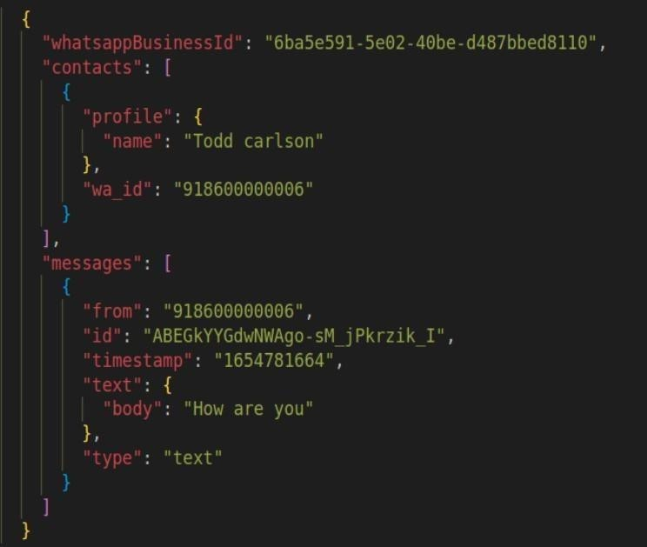

Contact Message
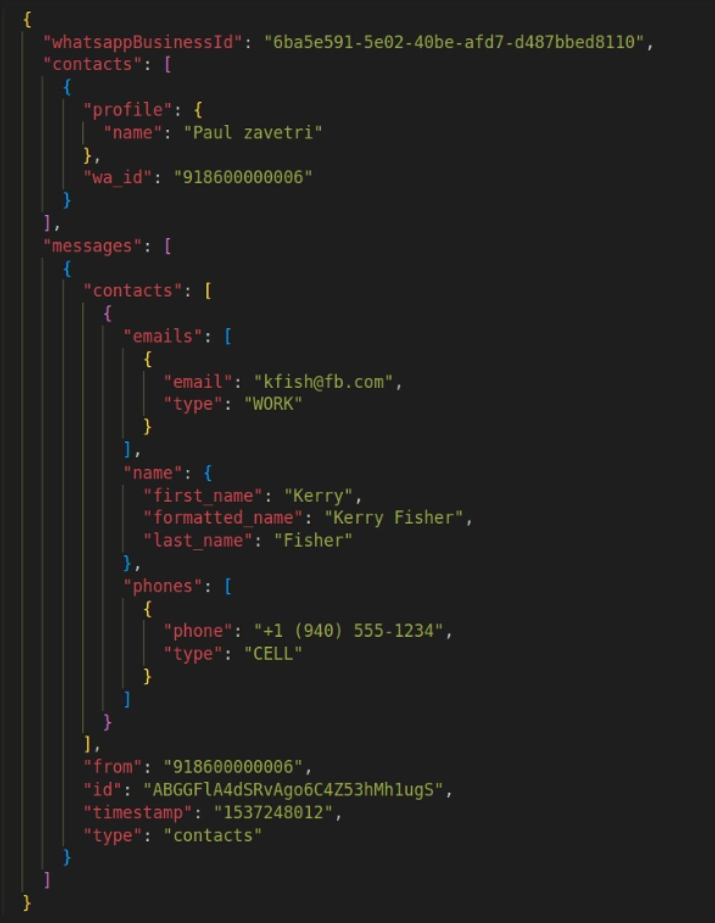

Location message
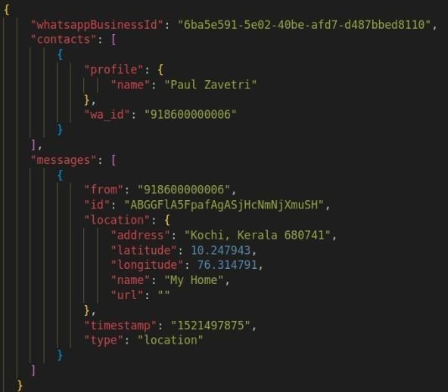
Button message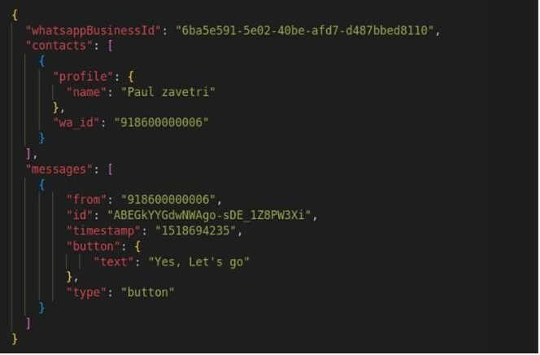
Image message
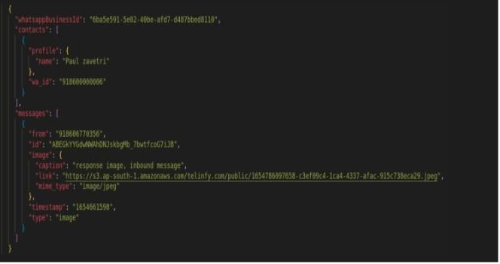

Video message
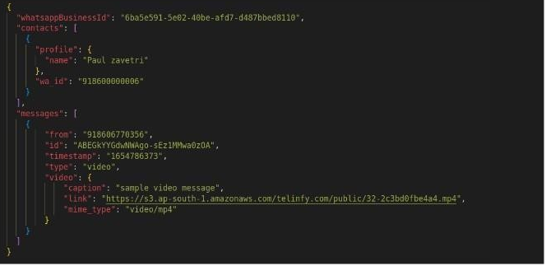

Audio message
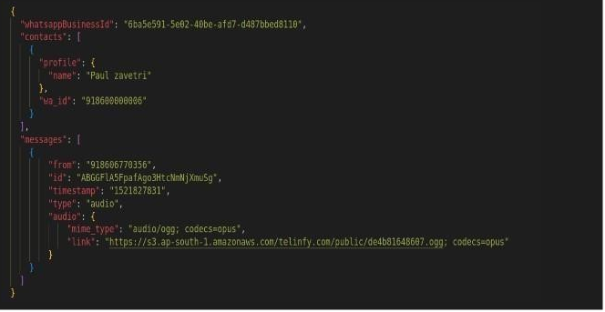

Sticker message
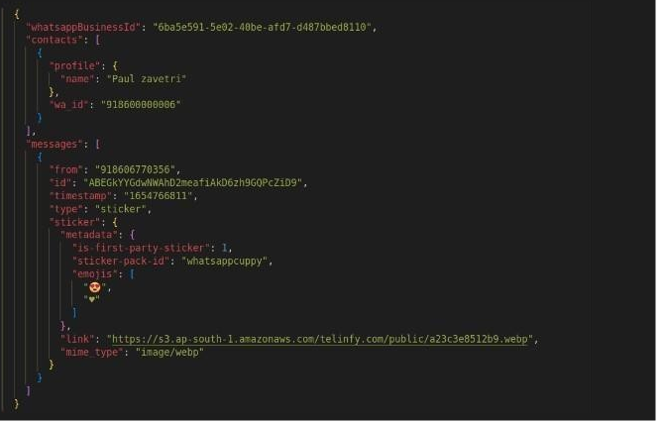

Document message
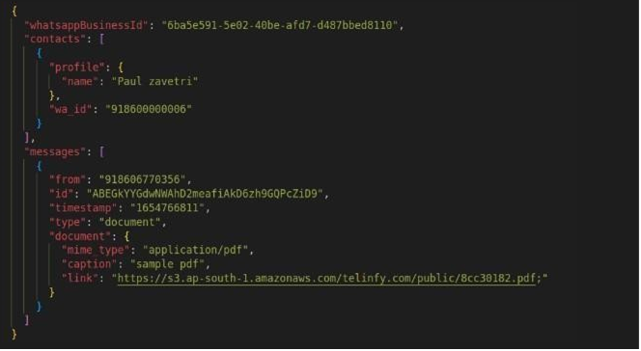

Unsupported Messages
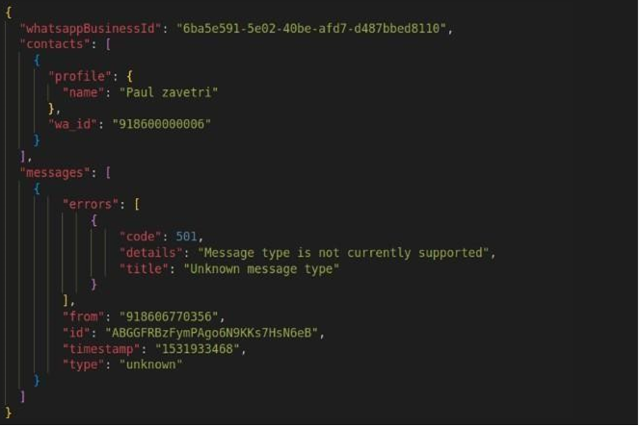

Interactive list-reply
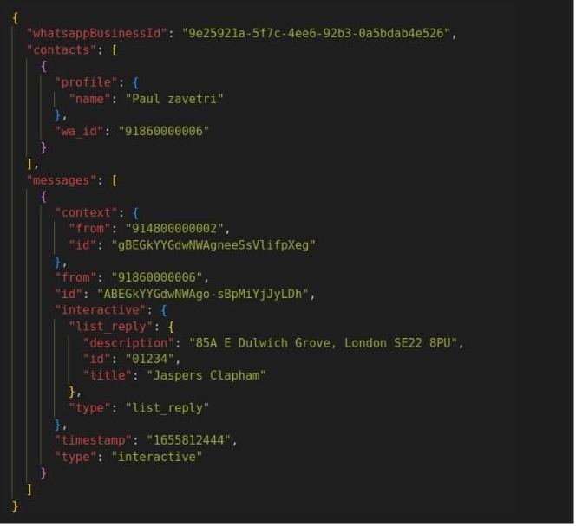

Interactive : Button reply

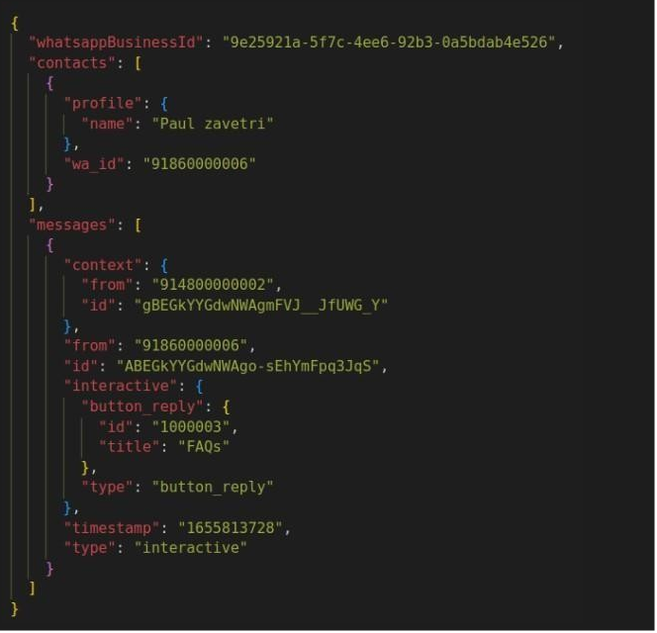

Customer Replied to Your Message
